Chemonite® ACZA Crossties 2013 Fall Update
Testing and Positive Evaluations Continue..
In 1983 a complete data package was submitted to AWPA and approved to support the use of ACZA as a wood preservative. As the preservative system has expanded its ability to protect wood products especially hardwood ties, Updated evaluation for the typical parameters required of new wood preservative treated wood products as well as evaluation of some particular properties of this preservative system have been conducted. Tests are either completed or in process. These evaluations include: spike holding, corrosion, conductivity, fire resistance, hardness, strength, and efficacy in hardwoods, test charges, with and without borates; develop AWPA Standard requirements for ties of Douglas-fir, hardwoods and pines, commercial usage, Life Cycle Analysis (LCA) and product enhancement through warranties.

SPIKE WITHDRAWAL
Force required to withdraw spikes from Douglas-fir railway ties.ª

Treatment | Withdrawal Force (lbs)
 | Before Exposure | After 1 Year of Exposure |  | After 2 Years of Exposure
 |  | Above Ground | On soil | Above Ground | On Soil
ACZA | 3753 ( 788) | 5905 (1269) | 5704 (1401) | 6340 (1634)^{b} | 6941 (1868)^{b}
Creosote | 3269 ( 641) | 4359 (1562) | 4686 (2039) | 5189 (1754) | 5408 (1574)
None | 3576 (1023) | 4964 (1621) | 5260 (1619) | 5146 (1367) | 5755 (1617)
ªBefore exposure withdrawal values based upon 30 replicates. One- and two-year exposure values represent means of 15 replicates per treatment. (Values in parentheses show one standard deviation.)
^{b}Values differ significantly from creosote ties in the same exposure at α=0.05.

Corrosion Testing

The spikes removed from each crosstie for the withdrawal testing were examined for evidence of corrosion. The spikes were measured at the approximate point where the spike emerged from the wood to determine if any cross-sectional loss occurred. The area on the spike where it emerges from the wood is an area where moisture and oxygen levels are optimal for corrosion. In addition, the spikes were cleaned and weighed to determine if weight loss had occurred.

After 2 years of exposure spike thickness loss was similar for ACZA and untreated ties; loss for the creosote ties was smaller. Overall, none of the spikes had a significant amount of thickness loss.
After 2 years of exposure, weight losses for spikes in all ties were less than 0.5% of their original weight. Weight loss of spikes in ACZA and untreated ties was similar with slightly lower losses for creosote ties. This is the same trend that was seen in the thickness losses.
Conductivity
While conductivity effects on poles were included in the 1983 AWPA package for preservative approval, conductivity is also a concern in tie installations due to signaling equipment used by railroads. Several types of tests have been conducted using actual poles, boards and even pellets of the dried preservative. In all tests ACZA treated wood products were found to be equivalent to untreated wood and research showed moisture content was the determining factor in conductivity rather than the preservative types. ACA and ACZA have been used in utility poles for over 50 years with no conductivity issues. A short line in Western Oregon, which has been using ACZA Douglas fir ties for over three years, installed ACZA ties in switch/signaling applications and found no conductivity issues. “We have 6 crossings with approximately 2,400 ties per crossing. All 6 crossings have AC-DC circuits, with no problems to the systems.” - Albany & Eastern R/R. Note the dampness on the ties in the figure below.

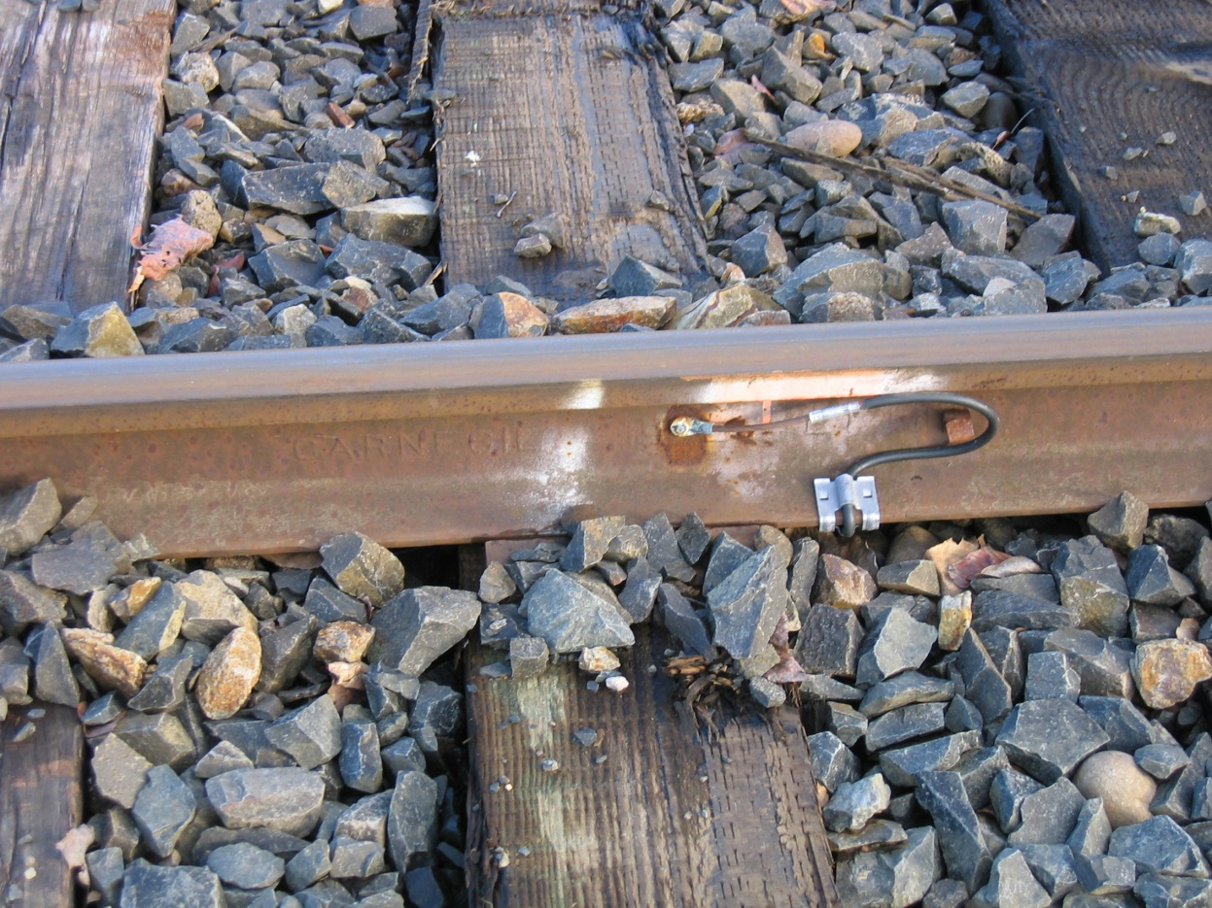

Fire Resistance
The effects of fire on wood products has always been a concern in its usage and any effect a preservative system may have on improving fire resistance increases the probability of continued or increase wood product usage. Historical testing done by U.S. Testing Labs and UL gave good indications that ACZA treated wood has fire resistant properties. ACZA treated wood is more difficult to ignite than untreated wood and at a retention of 0.35 pcf showed a flame spread rating of 41.7 and smoke development of 115.8 which meets the requirements for a Class B/II fire retardant. Current AWPA minimum retention requirement is 0.40 pcf. for ACZA ties and 0.60 pcf for poles. At retention of 1.86 pcf ACZA treated Douglas fir achieves a Class A/I fire retardant rating with a flame spread of 24.8 and a smoke development of 78.2. Results of these tests are summarized in Table 6.
Fire Resistance Testing
Species | size | Solution Strength | Retentionpcf | Flame Spread | Smoke Development
Doug fir | 2x6 | 2.46% | 0.35 | 41.7 | 115.8
Doug fir | 2x6* | 5.25% | 0.95 | 40.0 | 80.0
Doug fir | 2x6 | 6.96% | 1.37 | 30.9 | 36.9
Doug fir | 2x6 | 10.06% | 1.86 | 24.8 | 78.2
Doug fir | 2x6* | 12.40% | 3.20 | 25.0 | 20.0
*Samples were run by U.S. Testing labs, and by Underwriters Laboratories
“The Fire Retarding Properties of ACZA Treated Douglas fir and Redwood Lumber,” J.H. Baxter Technical Bulletin, 1997
Recent in house studies support these earlier results and the ability to include borates further increases fire resistance as shown in the Char Index below. More testing is planned for the near future.
Char Index
 | ACZA |  | 4.0kg/m³ | 4.0kg/m³ | 6.4 kg/m³ | 6.4kg/m³
 | With % BAE |  | N/A | +0.25 | N/A | +0.25
 | Species | Control
 | SY Pine | 96 | 65 | 48 | 52 | 40
 | D Fir | 52 | 38 | 36 | 36 | 32
 | R Oak | 60 | 42 | 39 | 47 | 32
 | Maple | 56 | 55 | 45 | 45 | 31

Physical Properties Testing
Testing of the effects of preservatives on physical properties includes determining their effect on the condition of the wood surface. Timber Products Inspection was retained to perform the ASTM D1037 Janka Ball Test to measure the effect of ACZA treatment on surface hardness. The results of the test are given in.

Hardness Testing
Test Number of Maple Specimens | Treated Ave. load  in lbs. force | Untreated Ave. Load  In lbs. Force
1 | 1165 | 1145
2 | 1242 | 1402
3 | 1123 | 1159
4 | 1169 | 1219
5 | 1163 | 1271
6 | 1209 | 1246
7 | 1209 | 1316
Ave. | 1183 | 1251
“ASTM D1037 Hardness Test”. Timber Products Inspection: Project No. A13-008, 2013. The results indicated there was no meaningful variation between the hardness of treated and untreated hardwood ties.

Additionally, the effect of preservatives on the strength of wood is important in determining if a preservative product can meet the requirements needed for intended applications. Mississippi State University was retained to test the effect of steaming and treating of hardwoods on the strength of hardwoods in Compression to Grain as well as in Static Bending. Results are given in the following.

Strength Testing - Compression ⊥ Perpendicular to Grain
 | Mean | Group
Red Oak: | ACZA vs Controls
A | 2,227 | UNT UNSTEAM | Only ACZA unsteamed lower than controls
A | 2,118 | UNT STEAMED | No deleterious effect of steaming on compression perpendicular to grain
A | 2,109 | ACZA STEAMED
B | 1,884 | ACZA UNSTEAM
Red Oak: | CREOSOTE vs Controls
A | 2,342 | CREO UNSTEAM | Controls same or less indicates no deleterious effects
BA | 2,227 | UNT UNSTEAM
BA | 2,217 | CREO STEAMED
B | 2,218 | UNT STEAMED
Sweetgum: | ACZA vs Controls
A | 1,416 | UNT STEAMED | Compared to unsteamed controls, no effect of steaming.
BA | 1,392 | UNT UNSTEAM
BA | 1,311 | ACZA UNSTEAM
B | 1,275 | ACZA STEAMED
Sweetgum: | CREOSOTE vs Controls
A | 1,598 | CREOSOTE STEAMED | Controls same or less indicates no deleterious effects
BA | 1,519 | CREOSOTE UNSTEAM
B | 1,416 | UNT STEAMED
B | 1,392 | UNT UNSTEAM

Static Bending
“Compared to untreated, steamed stock, no steaming treatment caused a significant reduction in any bending property evaluated. While there were differences among treatments, no clear trend emerged. When compared to untreated, unsteamed red oak, a drop of 10% or less was noted across all properties evaluated. This is consistent with published data which indicates a 10%, or less, drop in properties after treatment. From a strength and stiffness standpoint, steaming and subsequent treatment of red oak causes no problems and should be fine for treatments requiring steaming before treatment. “Dr. H. M. Barnes, MSU.
Preservative Efficacy
Obviously how well a preservative protects wood from biological attack is important in determining its potential uses, particularly for the protection of wood in industrial applications. ACZA has shown the ability to protect a variety of wood species from various wood attacking organisms. ACZA further protects wood from difficult-to-control insects – Formosan termites and Carpenter ants. ACZA has been classified as a Type III termiticide. Type III termiticides are slow acting, non-repellant materials, allowing termites to share the preservative throughout the colony – affecting the entire colony. Type I termiticides are repellants and Type II termiticides are contact poisons that may not affect the colony. Table 10 below shows how ACZA protects wood against termites when compared to untreated wood. Samples are treated and weighed prior to and after exposure to termites to determine the level of attack

Species | Preservatives | Fungi
Gum | ACZA | G. trabeum | Brown rot
Red Oak | CuN | P. placenta
White Oak | Penta | W. cocos
Red Maple | Creosote | P. subserialis | White rot
Red Pine |  | T. versicolor
X. frustulatus &
P. merismoides
Preservative | OSU Test  Retention | Sawn Mat’l  U1 Spec A  UC 4A | Crossties  U1 Spec C  UC4A-4C
Creosote | 8 pcf | 6-10 pcf  / Refusal | 7-8 pcf or refusal
Penta Type A | 0.40 pcf | 0.30-0.50 pcf  / Refusal | 0.35-0.40 pcf  / Refusal
CuN | 0.06 pcf | 0.06 pcf | 0.055-0.06 pcf  / Refusal
ACZA | 0.40 pcf | 0.40 pcf | 0.40 pcf
At ground contact standardized retentions, ACZA demonstrated good control of test fungi. Overall, in weight loss of ACZA blocks performed better than copper napthenate and pentachlorophenol and comparable to creosote. Soil block testing for efficacy of ACZA in hardwoods was done at Oregon State University and reported at the IRG in 1999.

Additionally a broad matrix of ties treatments with Chemonite ACZA Ties have been included in the most recent RTA AWPRP Project, the breakdown is below.

RTA-AWPRP Tie Preservative Matrix
RTA Tie Mix | ACZA | ACZA+DOT | ACZA+ET | ACZA +oil | ACZA + DOT + oil | ACZA + DOT + ET | P2 Creosote | Untreated Controls
Red Oak | x | x | x | x | x | x
White Oak | x | x | x | x | x | x
Douglas-fir | x | x |  |  |  | x | x | x

Full Scale hardwood cylinder charges were treated with ACZA; ACZA + Borates, ACZA + ET and ACZA + Borates + ET. Treatment results of two representative charges are below.

Treatment Results of Two Representative Charges
 | ACZA | ACZA |  | ACZA | ACZA | Borates | Borates
Species | 0.0-0.6” Zone | 0.6-1.0” Zone | Species | 0.0-0.6” Zone | 0.6-1.0” Zone | 0.0 -0.6”  Zone | 0.6-1.0” Zone
White Oak | 0.54 | 0.24 | White Oak | 0.48 | 0.22 | 0.42 | 0.24
Red Oak | 0.58 | 0.32 | Red Oak | 0.51 | 0.35 | 0.46 | 0.33
Gum | 0.86 | 0.49 | Gum | 0.64 | 0.35 | 0.71 | 0.61
 |  |  | Douglas-fir | 0.45 | 0.10 | 0.46 | 0.11
Penetration Charge Four:
White Oak - up to 3 inches
Red Oak – 1.1 inches to 3.0 inches (all cores exceeded 65% of annual rings)
Gum – 100% of sapwood penetration
D.fir - 0.4 inch to 0.6 inches of penetration

Penetration Charge Two:
White Oak – ranged from 1.75 inches to 2.75 inches
Red Oak - one core with less than 65% of annual rings penetrated it had 50% of the annual rings penetrated
Gum – 100% of sapwood penetrated

Our observed penetration results, especially for White Oak exceeded expectations. To confirm and verify the penetration results in White Oak ties in particular, CR Quality Services, Inc. an Independent Tie Inspection firm re-inspected the ties. The results are as follows:
- 140 pcs. Red Oak Crossties - The ACZA penetration was about the same as treatment with P-2 Creosote.
- 140 pcs. Mixed Gum Crossties - The ACZA penetration was about the same as treatment with P-2 Creosote.
- 140 pcs. White Oak Crossties – The ACZA penetration was better than crossties treatment with P-2 Creosote. The penetration was in to the heartwood.
- Bill Verbeck of CR Quality Services, Inc. Report issues Ocober 30, 2010.

Chemonite® ACZA Tie Treatment Standards
Based on the treating experience, ACZA treated hardwoods were submitted for and received approval for inclusion in the AWPA Book of Standards. Below are the treating requirements for the approved species for ties currently listed in the AWPA Book of Standards. ACZA preservative is listed in Standard P-22 and treated wood products are listed in the American Wood Protection Association (AWPA) Standard U1, Commodity Specification C T1 Section C.
Current AWPA Standards Treatment Requirements 2013
Species | ACZA Assay Retention /PCF.
Oak, Hickory | 0.40
Mixed Hardwoods | 0.40
Southern & Ponderosa Pine | 0.40
Coastal Doug-fir, Western Hemlock, Western Larch | 0.40
Intermountain Doug-fir | No data
Jack, Red & Lodge Pole Pine | 0.40
------------------------------------------------------------------------- | --------------------------------------------------------
Species | ACZA Penetration
Oak, Hickory | WO- 95% of sapwood (d)  RO – 65% of annual rings(c)
Mixed Hardwoods | 1.5”or 75% (a)
Southern & Ponderosa Pine | 2.5”or 85% of sapwood
Coastal Doug-fir, Western Hemlock, Western Larch | 0.5”and 90% (b)
Intermountain Doug-fir | 0.5”and 90% (b)
Jack, Red & Lodge Pole Pine | 0.5”and 90% (b)

- Whenever “or” is specified, it shall be interpreted to mean whichever is less.
- Whenever “and” is specified, it shall be interpreted to mean whichever is greater.
- Red Oak penetration must average a minimum 65% on twenty 3.0” cores.
- ACZA White Oak must also have a minimum heartwood penetration of 33% in twenty 1.5” cores.
- Incising is required for Cypress, Coastal Douglas-fir, Western Hemlock, Western Larch, Intermountain Douglas-fir, Jack Pine, Lodge Pole Pine and Red Pine.
- Incising is optional for Oak and Hickory, Mixed Hardwoods, Southern Pine and Ponderosa Pine.

The seven charges of treated hardwood ties were returned to the east coast for installation. Most were installed in SW Florida, SE Georgia and Eastern North Carolina. The North Carolina site is a Hazard Zone 4 exposure, the Georgia site is a Hazard Zone 5 exposure site and the SW Florida site is a Hazard Zone 5+ exposure where the life expectancy of creosote treated hardwood ties has been 7 years. Effective 2013, Mississippi State University will provide evaluation service for these ties.

Installation Test Tie Sites
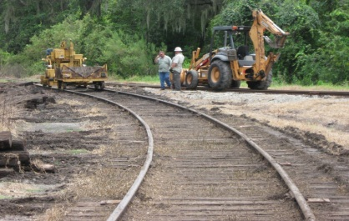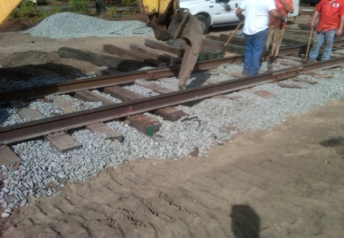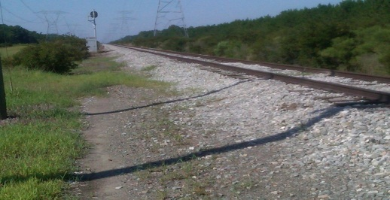
SW Florida Site Eastern NC Site SE Georgia Site

Old and New Ties in SW Florida
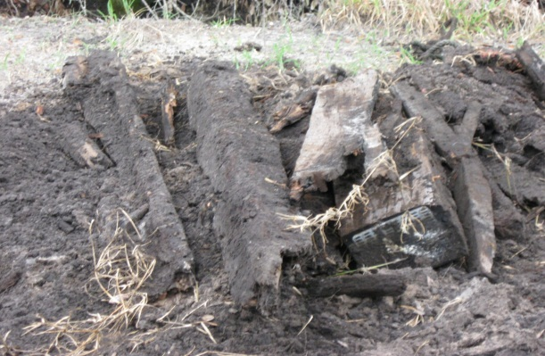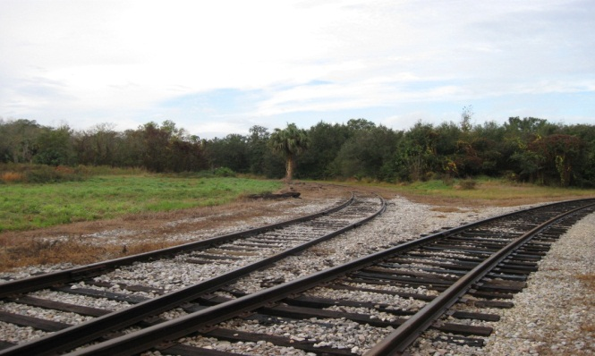
Seven Year Old Ties Removed ACZA Hardwood Ties after 18 months

The Original Douglas-fir Ties were visually observed after three years of exposure in Western Oregon. The Railroad was pleased with the results to date.

ACZA Douglas-fir 3 + Year Old Ties
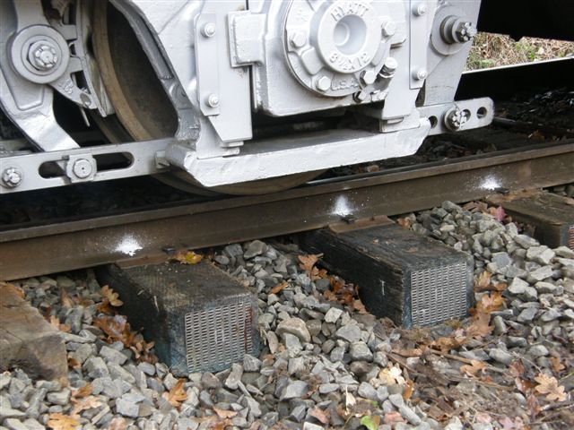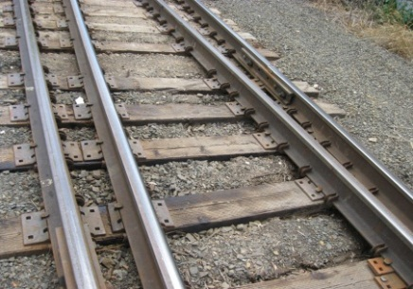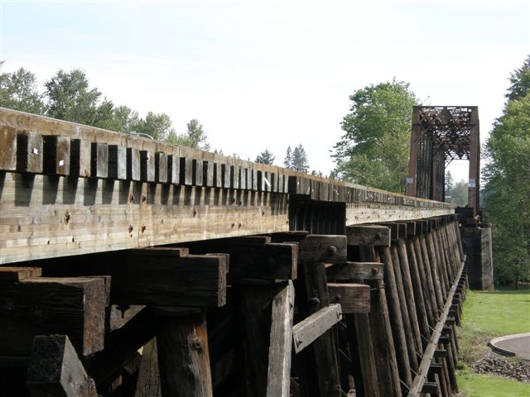
Under Load Switch Ties Bridge Ties and Laminated Beams

Hardwood Ties Being Treated in Canada for Railroad Use.
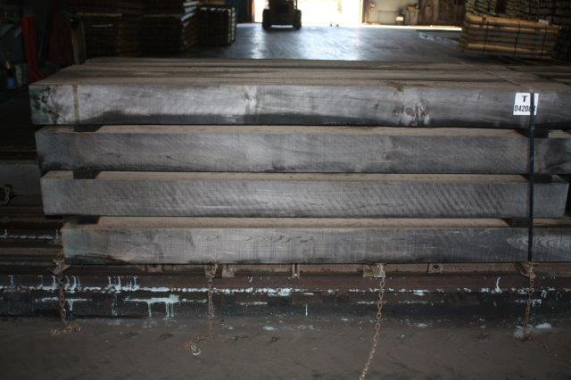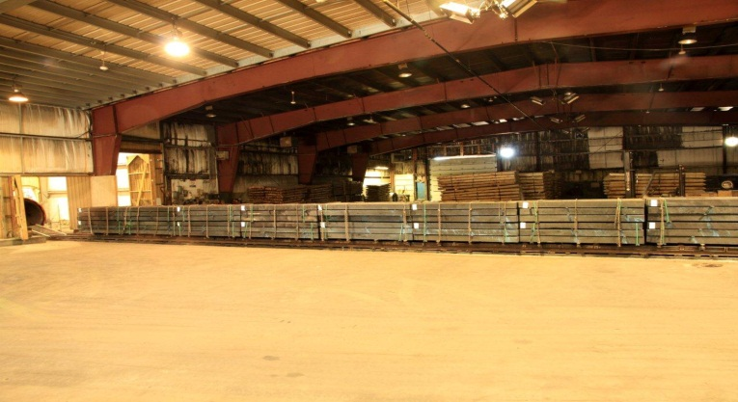

Canadian ACZA Hardwood Tie Installation
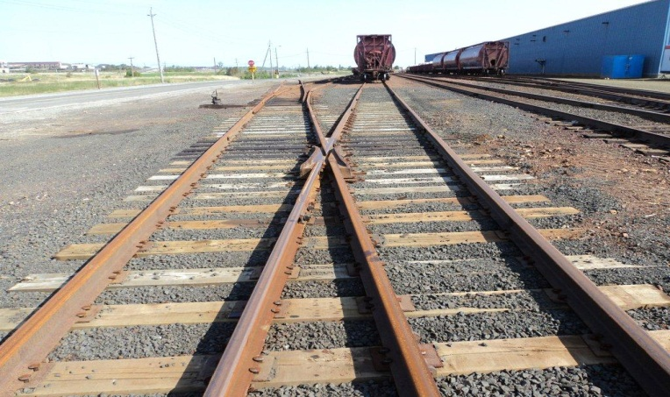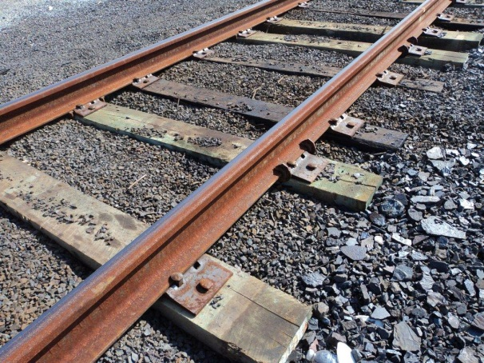
Life Cycle Analysis (LCA)
Materials are being evaluated on their environmental footprint. ACZA treated wood has been no different. As a part of the ongoing evaluation of ACZA and its stewardship of the environment, AqueTer was contracted to perform a Life Cycle Analysis (LCA) in comparison with alternative products for its main uses.
For ties the comparison was with concrete and plastic/composite ties. As indicated in the table: ACZA tie production and usage has less impact on Green House Gases (GHG), fossil fuel use, acid rain contribution, smog contribution, eutrophication and ecological toxicity over their entire life span from raw material to disposal.
Life Cycle Analysis (LCA) for ACZA Ties
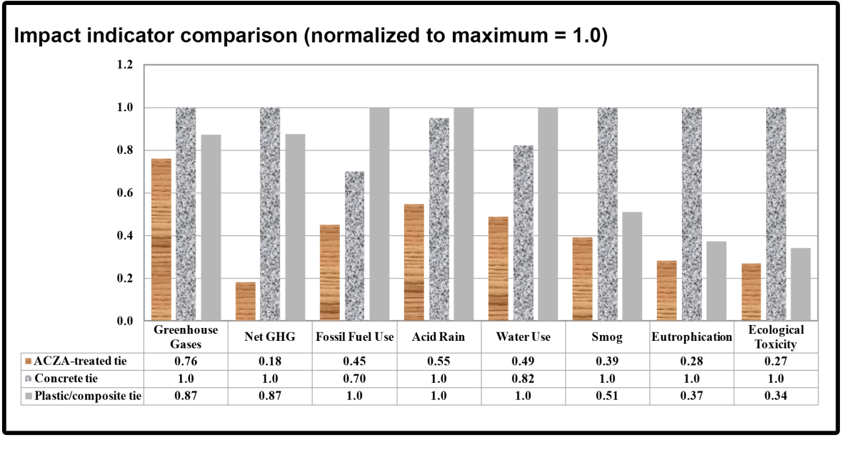

Warranties
Limited product warranties are now in place for hardwood ties, Douglas-fir ties and Southern Pine ties and timbers. Go to www.chemonite.com for more information.

AZCA has protected wood for over 30 years from wood destroying organisms without undue effect on the properties of the wood it is protecting including strength, corrosion and conductivity. It can treat refractory species and performs well in the harshest of environments - salt water exposure and is leach resistant, offers fire protection, and good fastener holding characteristics. Being able to blend borates into the treating solution only improves ACZA against wood destroying organisms, fire and corrosion. Product enhancements can be used to improve surface characteristics. These abilities, characteristics, properties and uses make ACZA a versatile wood preservative system.

